Use-Case Realization Report
UpdateCustomer

Issue <1.0>
Revision History
Date | Issue | Description | Author
<02/08/09> | <1.0> | <UpdateCustomer> | <Karen Gao>

Table of Contents
1. Brief Description 4
2. Flow of Events 4
2.1 Standard Flow 4
2.2 Exceptions 4
3. Interaction Diagrams 5
3.1 Collaboration Diagram for UpdateCustomer 5
4. Participating Objects 5
5. Class Diagrams 6
5.1 Class Diagram for UpdateCustomer 6
6. Derived Requirements 6

Use-Case Realization Report
UpdateCustomer

Brief Description
The update of Customer shall be executed once the check for the selection of the existing Customer list and validation of updates were performed.

Flow of Events

Standard Flow
This use case covers the events of updating Customer, which is part of the Maintenance Customer package. The standard flow of events is described as below:
- The Portal Administrator shall press the button to send out a command of “updateButtonClicked” on the interface of CustomerPage.
- Once CustomerController received this request, the operation checkCustomerToUpdate will check if there’s Customer seleted.
- Then the operation getCustomerInfo will get the customer from object of Customer, and show to the CustomerPage through the operation displayCustomer.
- The Portal Administrator shall press the button of updateSaved to Customer Controller, and it will check for the validation of updates.
- Subsequently, the operation updateCustomer will sent the updated Customer in the customer List from object of customer.
- Once it’s done, the successful updating Customer will show to the CustomerPage through the operation showCustomerList.

Exceptions

- If there’s no selection found in Customer records, a warning message will be show to the CustomerPage through the operation showNoCustomerSelectedMsg.
- If there’s invalidation found, a warning message will be show to CustomerPage through the operation showUpdatesInvalidMsg.

Interaction Diagrams

Collaboration Diagram for UpdateCustomer
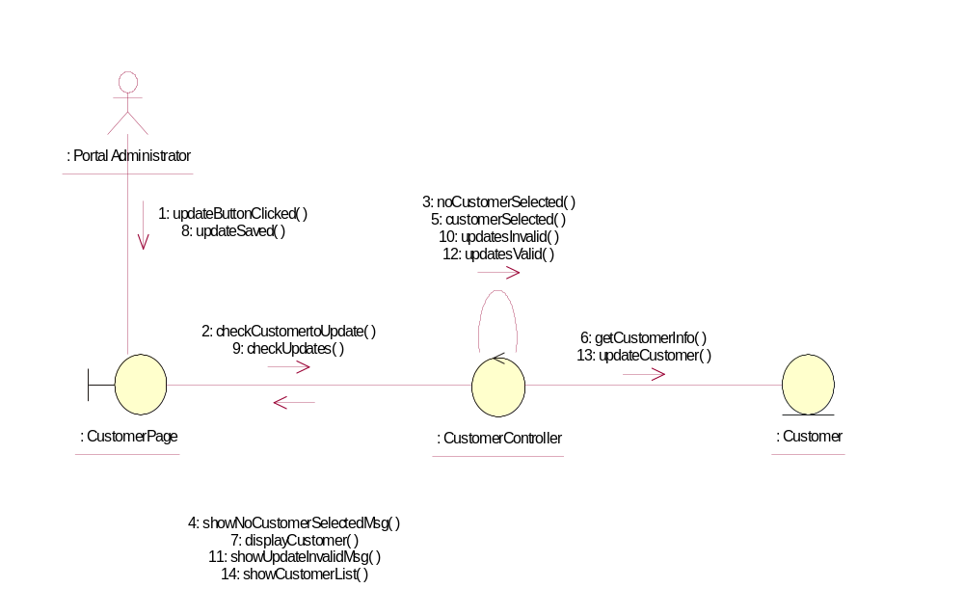

Participating Objects
: Customer
This Entity is Customer object

: CustomerController
This controller is to add, delete and update Customer

: CustomerPage
This is a page for adding, deleting, updating and displaying the Customer

: Portal Administrator
This is the super user of the system

Class Diagrams

Class Diagram for UpdateCustomer
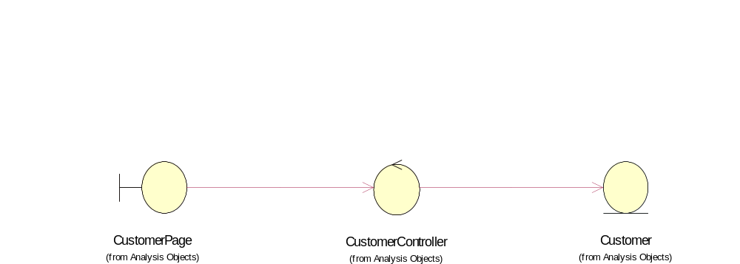

Derived Requirements
Only Portal Administrator has rights to access this page

